**QSF Editor Procedures**

1. Do A2Q on the QSF file
2. Open the QSF file you’d like to work on in QSF editor (QSF Editor 2) (In this example, CollectIN.qsf is going to be used)
3. On the right, under files, right click on "CollectIN.qsf" and then click script

1. Paste in script “ExcelImport.txt” from here-[QSF script](https://icfonline.sharepoint.com/sites/ihd-dhs/dataprocessing/Software/Forms/AllItems.aspx?viewpath=%2Fsites%2Fihd%2Ddhs%2Fdataprocessing%2FSoftware%2FForms%2FAllItems%2Easpx&id=%2Fsites%2Fihd%2Ddhs%2Fdataprocessing%2FSoftware%2FQSF%20Editor&viewid=34824e51%2D9c6e%2D4041%2D8ffd%2D14f0ecb33712)

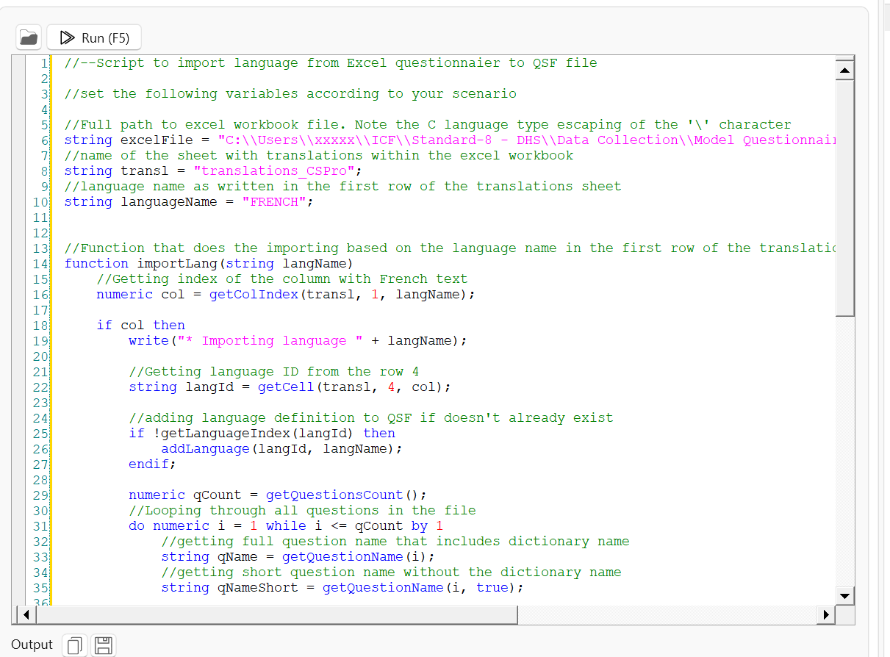

1. In the script, edit the text: Change the excel source path (string ExcelFile) and language import (string Languagename)

Note: You have to do each language separately

1. Click "run"
2. Check output for errors-see if there are any questions where there is supposed to text and it didn’t import it-if there are any issues like this, check the Excel file and make the necessary edits
3. Then save
4. Run the "audit" to check any blank questions or other issues as well

To update the translations in the “translations_CSPro” tab in the XLSX file, go to “data” and then “Refresh all”. Highly suggest doing this before importing the languages. Note: you can see the last run of the refresh all in cell D2.

For CS variables, there is no text in the QSF for that question, therefore not in the QSF file, and the QSF reader doesn’t know that there should be something there. What you need to do is put a least some text (like a period) in the question text for all the CS questions. Then in the QSF file, there will be the CS questions.

If you want to do an audit of what questions don’t have text, in CSPro, go to “CAPI” and click on “question text macros”, and then click on “include blocks”, and then click on “audit undefined text”

**Helpful tip**: to increase QSF text size go under "Style" and change it